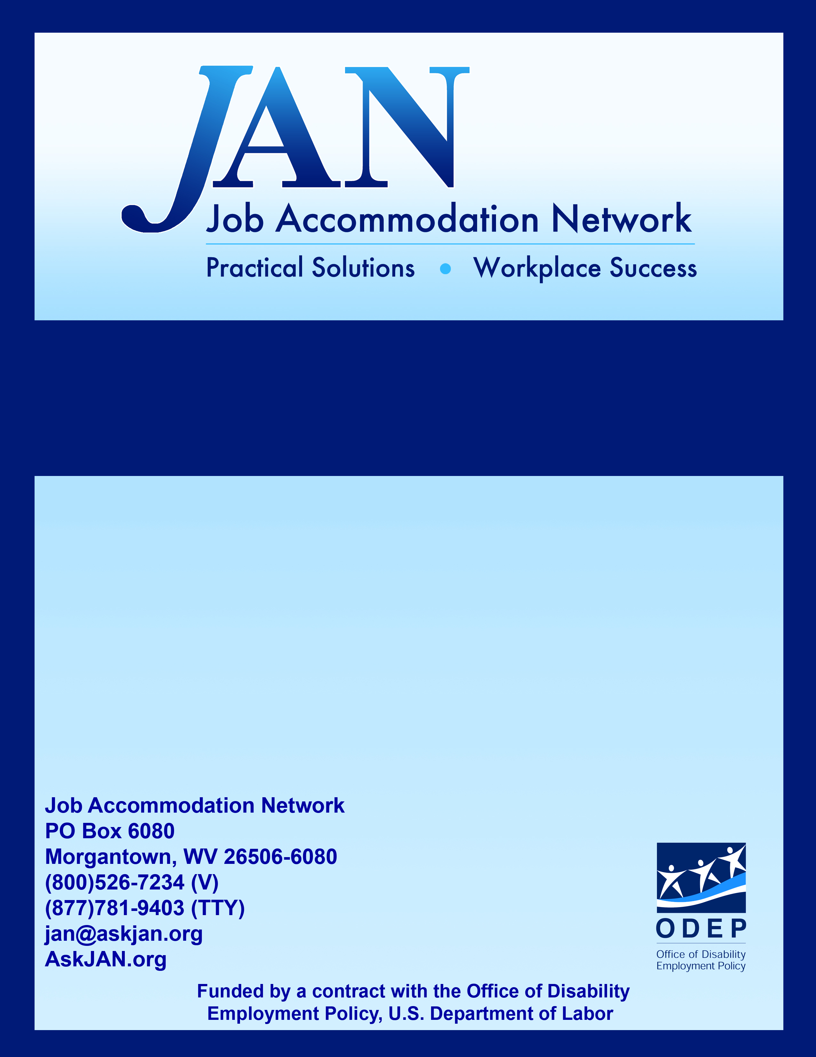
Monitoring Reasonable Accommodations

Effective Accommodation Practices (EAP) Series

JAN’S EAP SERIES

Monitoring Reasonable Accommodations

Interactive Accommodation Process
The Americans with Disabilities Act (ADA) requires covered employers to provide effective, reasonable accommodations for employees with disabilities. There is no required process for providing accommodations under the ADA, but it is recommended that employers engage in what is known as an “interactive process” to collaboratively explore accommodation solutions with individuals with disabilities who request accommodations. Private employers have the freedom to develop their own policies and procedures for implementing the interactive process. There is no standard procedure.
Employers who wish to draft their own policies and procedures will benefit from reviewing the Equal Employment Opportunity Commission’s (EEOC) own procedures for providing reasonable accommodations for individuals with disabilities, as well as the agency’s Practical Advice for Drafting and Implementing Reasonable Accommodation Procedures under Executive Order 13164.
Another practical resource that can be useful to employers when engaging in the interactive process is JAN’s six-step sample Interactive Process. This process can be found at AskJAN.org under A to Z By Topic: Interactive Process. Briefly, the steps in the process include:
Step 1: Recognizing an Accommodation Request
Step 2: Gathering Information
Step 3: Exploring Accommodation Options
Step 4: Choosing an Accommodation
Step 5: Implementing the Accommodation
Step 6: Monitoring the Accommodation

Monitoring Accommodations
The final step in JAN’s Interactive Process, Monitoring the Accommodation, is frequently disregarded after an accommodation has been implemented. It is worth noting that as important as it is to explore, choose, and implement accommodations, it is equally as important to ensure that accommodations continue to be effective after implementation. Accommodations can stop being effective for various reasons, such as: the employee’s limitations change, workplace equipment changes, the job changes, the workplace itself changes, or the accommodation becomes an undue hardship for the employer to continue to provide.
Because changes occur, employers may need to periodically check on the ongoing effectiveness of accommodations. If equipment is involved in the accommodation, someone may need to be assigned to perform maintenance or upgrades, as needed. The most important way to monitor accommodations is to encourage ongoing communication. Employees who are receiving accommodations should be encouraged to communicate with the employer when there are changes or problems with an accommodation, and should know who to contact for assistance.
When monitoring accommodations, keep in-mind that accommodations must be effective in meeting the needs of the individual. In the context of job performance, this means that a reasonable accommodation enables the individual to perform the essential functions of the position. Similarly, a reasonable accommodation enables an applicant with a disability to have an equal opportunity to participate in the application process and to be considered for a job. Finally, a reasonable accommodation allows an employee with a disability an equal opportunity to enjoy the benefits and privileges of employment that employees without disabilities enjoy. Keep these tips in-mind when monitoring accommodations:
- Check on effectiveness. As things change in the workplace, accommodations may need to also change so employers should periodically check the effectiveness of accommodations.
- Maintain the accommodation. Equipment will not function forever without maintenance. When equipment is part of an accommodation, employers need to make sure the equipment is properly maintained.
- Encourage ongoing communication. For any workplace issue, ongoing communication is the key to success. The same is true for accommodations. Employers should encourage employees to communicate any issues they have with their accommodations.
- Restrict medical inquiries. Inquiries should focus on the effectiveness of the accommodation, as opposed to details related to the medical impairment. For information about medical inquiries and the ADA, see JAN’s A to Z by Topic: Medical Exams and Inquiries.
- Document findings. If the accommodation remains effective, make a note of it. If changes are necessary, explore, choose, and implement changes, and document actions taken to resolve the situation.

Sample Form for Monitoring Accommodations
There is no standard process for monitoring accommodations. Sometimes employers are unaware of the types of questions or concerns that may need to be addressed. It can be useful to follow a checklist or use a form to guide and document the process. JAN has developed a sample form (http://AskJAN.org/topics/Sample-Forms.cfm) be used as a guide when monitoring accommodations. This form may be customized to gather information relevant to each unique situation. Please note that this sample form is to be used as a guide only and is not legal advice. If legal advice is needed, contact a legal service. Updated 05/31/2018

This document was developed by the Job Accommodation Network, funded by a contract from the U.S. Department of Labor, Office of Disability Employment Policy (#1605DC-17-C-0038). The opinions expressed herein do not necessarily reflect the position or policy of the U.S. Department of Labor. Nor does mention of tradenames, commercial products, or organizations imply endorsement by the U.S. Department of Labor.

